National Science Foundation: Research Experience for Undergraduates
Ocean Acidification at a Crossroad – Cruise Plan
10nd – 15th August 2021

A. CRUISE OVERVIEW

- Platform: R/V Pelican
- Cruise Description:
The 2021 XR02 Cruise is a NOAA funded cruise. The cruise is the second of three cruises scheduled aboard the RV Pelican in 2021. The project lead is Xinping Hu (TAMUCC); SF DiMarco (TAMU/GERG) is ship-board and autonomous vehicles operations lead and will serve as Chief Scientist

- Schedule:
9st August: Depart College Station approximately 9 a.m. and drive to Cocodrie, LA. Travel time is approximately 8 hours. Dinner onshore, mobilize. Depart at port at midnight.
10th August: Onboard
11st August: Onboard
12nd August: Onboard
13rd August: Onboard
14th August: Onboard
15th August: Return to port approximately 12 noon. Demobilize.
Return to College Station.

- Objectives:
1. Perform sampling lines from Terrebonne to the Flower Garden Banks National Marine Sanctuary to Galveston and return to LUMCON;
2. Collect shipboard acoustic current velocity profiles;
3. Collect underway surface properties using the ship’s flow-through system;
4. Collect vertical profiles of hydrographic properties using CTD and 12-bottle rosette system. Collect fluorometric, PAR, light transmission, and beam attenuation data as part of the CTD system package (approximately 22 CTD stations);
5. Collect dissolved nutrients and oxygen samples for chemical analysis;
6. Collect carbon system samples (DIC, CO2, etc) (Hu);
7. Collect 5-L water carbuoys (Shamberger [not on vessel))
8. Collect colored dissolved organic matter samples (Gold-Bouchot)
9. Deploy SV3 Liquid Robotics WaveGlider (if conditions and equipment allow)

B. SCIENCE OPERATION
Mobilization will be in Cocodrie, LA. The cruise will complete a triangular pattern joining Cocodrie, LA to The Flower Garden Banks National Marine Sanctuary (Line 2 -L2), The Flower Garden Banks to Galveston Island (Line 1 -L1), and Galveston Island to the Cocodrie, LA (Line 2 -L3). On each line, 3 to 6 CTD casts will be completed at predefined stations. A total of 23 CTD stations are planned (Figure 1). Table 1 shows the sequence of stations and the transit distance and times at a cruising speed of 8.0 knots. It is expected to take approximately 93 hours to complete this cruise track plus approximately 12 hours of on-station time. CTD casts should take roughly 40 minutes each or ~12 hours to do the roughly 23 casts. The additional station time will be accounted for additional adaptive sampling and a possible deployment of the SV3 WaveGlider autonomous vehicle. 24-hour continuous operations will be required, and 12-hour watches will be assigned to the science party.

Figure 1. Planned station locations for the 2021 XR02 cruise.
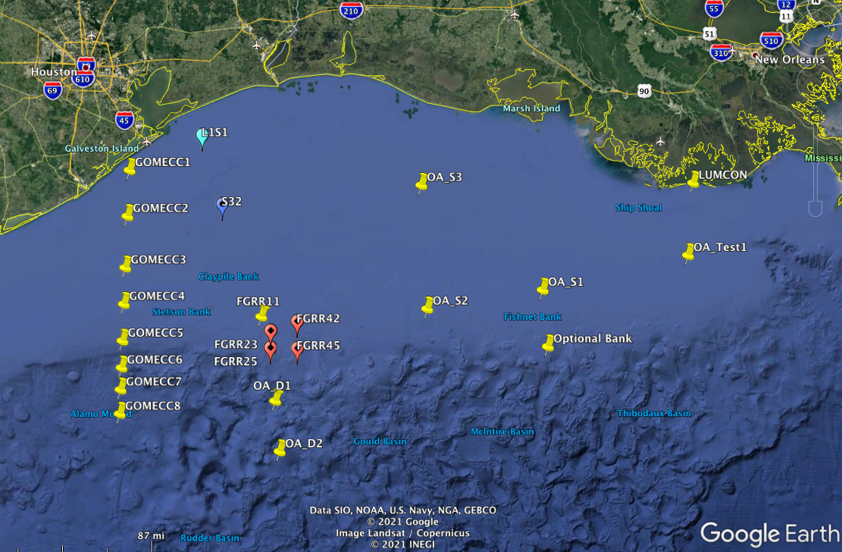

Table 1. Cruise track planning summary (subject to change). This timetable shows the travel time between stations but does not account for CTD cast time (on station time is ~15 minutes).

Arrive Time Range Bearing Time Depart Depart Local
Time on --to next station--- time time Time
Longitude Latitude Station hrs hrs km true hrs hrs days Hours
-90.600000 29.000000 LUMCON 0.00 0.27 121.323 53 8.19 0.27 0.01 0.27
-91.606500 28.359800 OA_Test 8.46 0.24 20.348 52 1.37 8.70 0.36 8.70
-91.772500 28.249800 OA_S1 10.07 0.25 42.728 359 2.88 10.32 0.43 10.32
-91.771900 27.865700 OA_Bank 13.21 0.40 97.267 62 6.56 13.60 0.57 13.60
-92.650300 27.466600 OA_D3 20.17 0.89 120.081 70 8.10 21.06 0.88 21.06
-93.800300 27.119100 OA_D2 29.16 0.84 39.269 180 2.65 30.00 1.25 6.00
-93.799400 27.472100 OA_D1 32.65 0.81 34.633 157 2.34 33.46 1.39 9.46
-93.932300 27.760300 FGRR45 35.80 0.27 36.492 243 2.46 36.07 1.50 12.07
-93.600900 27.907700 OA_EB 38.53 0.19 7.275 157 0.49 38.72 1.61 14.72
-93.629000 27.968200 FGRR42 39.21 0.27 17.985 103 1.21 39.48 1.65 15.48
-93.807200 28.005300 OA_21 40.70 0.26 11.593 9 0.78 40.95 1.71 16.95
-93.826600 27.902500 FGRR23 41.74 0.27 3.386 339 0.23 42.01 1.75 18.01
-93.814500 27.874000 WEST_BUOY 42.24 0.22 131.505 62 8.88 42.46 1.77 18.46
-95.000600 27.333000 GOMECC8 51.33 1.00 18.489 180 1.25 52.33 2.18 4.33
-95.000300 27.499200 GOMECC7 53.58 0.84 16.698 180 1.13 54.41 2.27 6.41
-94.999000 27.649300 GOMECC6 55.54 0.70 20.435 179 1.38 56.24 2.34 8.24
-94.999800 27.833000 GOMECC5 57.62 0.39 27.899 179 1.88 58.02 2.42 10.02
-95.000000 28.083800 GOMECC4 59.90 0.24 27.665 179 1.87 60.14 2.51 12.14
-95.000700 28.332500 GOMECC3 62.00 0.20 39.078 180 2.64 62.21 2.59 14.21
-94.999700 28.683800 GOMECC2 64.85 0.19 34.939 180 2.36 65.04 2.71 17.04
-94.999400 28.997900 GOMECC1 67.39 0.18 78.177 290 5.28 67.57 2.82 19.57
-94.247500 28.752100 OA_S32 72.85 0.19 149.138 259 10.07 73.04 3.04 1.04
-92.743000 29.001000 OA_S3 83.11 0.19 72.285 270 4.88 83.29 3.47 11.29
-92.000000 29.000000 OA_MCH 88.17 0.18 136.203 270 9.19 88.35 3.68 16.35
-90.600000 29.000000 LUMCON 97.54 0.18 0.000 0 9.19 97.72 4.07 1.72

The regular station activity will be the deployment of the CTD to the near-bottom of each station.

Water samples collected from the Niskin bottles during CTD casts bottles will be taken in the following order:
1. Oxygen
2. DIC/TA
3. Nutrients
4. CDOM (if possible)
6. Salinity

All 12 bottles will be fired at all stations, unless the stations are in 50 m or less (total depth).
After departure from Cocodrie, we will transit to 28.5 N, 90.6 W for the first CTD station (OA_Test). Transit time will be approximately four hours. Working towards the Flower Garden Banks, we will complete OSS1, OA_Bank (optional), and OAS2.. Heading towards Galveston, we will then complete FG45, FG42, FG11, FG23, and FG25. If the SV3 is deployed, it will occur at station FG11. Following FG25, we will transit offshore to stations OA_D1 and OA_D2.Then, head west and onshore to run the GOMECC line stations 8 through 1. Then return east to station S32. From S32 the cruise time to Cocodrie is approximately 24 hours. We will plan to monitor time closely so to fit in adaptive sampling stations and ensure on time return to port.

C. CONTACT
PI CONTACT INFORMATION
Chief Scientist: Dr. Steven DiMarco
Department of Oceanography
Texas A&M University
College Station, TX 77845
Office: 979-862-4168
Cell: 979-324-5336
Email: sdimarco@tamu.edu

D. SCIENCE PARTY
LIST of PARTICIPANTS
Chief Scientist
Dr. Steven F. DiMarco
Senior Scientists
Dr. Xinping Hu (TAMUCC, Lead PI)
Dr. Piers Chapman
Dr. Kerri Whilden (GERG)
Postdoc
Dr. Hang Yin
Marine Technician
CJ Staryk
Graduate Students
Xiao Ge
Reshmi Joseph
Samantha Longridge
Sakib Mahmud
Ellen Laake
Molly Brzezinski
Nicole Kumbala
Kenzie Merril

E. R/V PELICAN CREW
Captain:
Able Seaman:
Chief Engineer:
Assistant Engineer:
Chef:
Marine Technician:

E. EQUIPMENT TO BE PROVIDED BY PROJECT
Liquid Robotics WaveGlider autonomous vehicle (SV3, TAMU)
Winkler titration system (TAMU)
Three boxes of oxygen bottles
300 nutrient tubes
Coolers
Filters and syringes
100 salinity bottles
Computers
Additional flasks and tubing
Six carboys (TAMU)
Chemicals
MSDS sheets

F. EQUIPMENT TO BE PROVIDED BY R/V PELICAN
Shared use equipment including the CTD/Rosette System, computer hardware, and network are listed on the R/V Pelican cruise planning manual.
G. EMERGENCY CONTACT INFORMATION:
In case of emergency messages, the R/V Pelican can be reached directly or via the LUMCON Marine Center. LUMCON Marine Center phone number is (985) 851-2800. During normal working hours, they can relay your message by radio or by email to pelican@lumcon.edu or pelican07@boatracs.com.

H. CREW SERVICES TO BE PROVIDED BY RV PELICAN
Meals, snacks, and beverages will be provided. Towels and linens will also be provided.

I. TANK AND WEIGHT NEEDS
None. No diving planned.

J. HAZARDOUS MATERIALS
MSDS sheets will be brought to Cocodrie at time of cruise.

- BUNK AND WATCH ASSIGNMENTS
Stateroom Number Watch

2 Chapman Day 6 a.m. – 6 p.m.
2 DiMarco Day/Night 6 a.m. – 6 p.m.

3 Nicole Kumbala Night CTD 6 p.m. – 6 a.m.
3 Kerri Whilden Day SV3 6 a.m. – 6 p.m.

4 Kenzie Merrill Night CTD 6 p.m. – 6 a.m.
4 Molly Brzezinski Day CTD 6 a.m. – 6 p.m.
4 Reshmi Joseph Day CTD 6 a.m. – 6 p.m. Day Datacop
4 Sam Longridge Day CTD 6 a.m. – 6 p.m.

6 Xiao Ge Night CTD 6 p.m. – 6 a.m. Night Datacop
6 Sakib Mahmud Night CTD 6 p.m. – 6 a.m.
6 Xingping Hu Day 6 a.m. – 6 p.m.
6 CJ Staryk Day Lab 6 a.m. – 6 p.m.

7 Ellen Laaker Day CTD 6 a.m. – 6 p.m.
7 Hang Yin Night Lab 6 p.m. – 6 a.m.

J. COVID-19 Precautions

Guidance for COVID-19 mitigation will be given by the vessel operations director.. Science Party will abide by guidance and restrictions contained therein.
K. Project Notes:

We plan to provide a context for answering the following linked questions, followed by testing their respective hypotheses:

Q1. What is the effect of nutrient input on the seawater carbonate chemistry in the shelfslope regions of the nwGOM?

H1. Nutrient input from terrestrial sources (hence metabolic CO2) can influence not only the continental shelf but the upper slope region of the nwGOM.
H2. Due to the effect of ocean circulation, the nutrient level (hence the metabolic CO2 buildup) in the upper water column of nwGOM is increasing.

Q2. How does the carbonate chemistry change spatially and temporally in the nwGOM shelf/slope region?

H3. Carbonate chemistry will respond not only to the pulses of large river discharge (across Louisiana and Texas) but also to the meteorological forcing (wind) and ocean current that can bring up cooler high CO2 water to the surface or shallow subsurface.
H4. Carbonate chemistry will respond to the influence of nutrient input and wind the most in areas surrounding the salt domes where intense upwelling may occur.

Q3. What are the short-term and long-term projections of OA in the shelf/slope waters of the nwGOM.

H5. Surface water will largely follow the atmospheric CO2 increase with the exception of the areas subject to upwelling, subsurface water will experience enhanced acidification effect due to the influences of atmospheric CO2, terrestrial nutrient input, and upwelling.
H6. The combined nutrient input, upwelling, and atmospheric CO2 increase will amplify ocean acidification signals by increasing its magnitude and severity of shelf water acidification in the future.

